“Preserving our worlds”
COMENIUS 2008-2010
ITALY, GERMANY, NORTHERN IRELAND, SLOVAKIA, SPAIN

“alla Milanese” Rice

Ingredients for four people
• 12 handfuls of rice
• 50 grams butter,
• 30 grams of crushed marrow bone
• 2 tablespoons of gravy
• 2-3 litres of boiling broth,
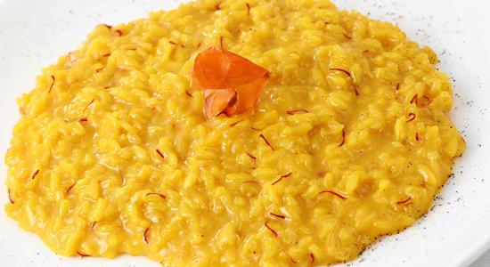
• 1 small onion
• a piece of butter
• 1 sprig of saffron or 1 sachet of saffron
• grated parmesan cheese.
• You can add 20 grams of dried mushrooms or 1 sliced white truffles over the cooked ‘risotto’
Preparation:
Put in a pot the marrow bone, the butter, the gravy and the onion, sliced thin, let it cook gently over low heat, to let the onion get a golden colour. If you don’t add gravy, put 60 grams of crushed marrow bone instead of 30. Add rice and stir well so that it can absorb the sauce. Then raise the heat and begin to pour ladles of hot broth on rice, stirring regularly with a wooden spoon. When the broth evaporates and is absorbed, keep adding some broth and continue to cook the rice until cooked,
paying attention that the rice remains ‘al dente’ (it must be still a little bit raw inside so cook from (14 to 18 minutes).
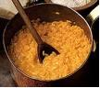

Rice and marrowbones

Ingredients for four people

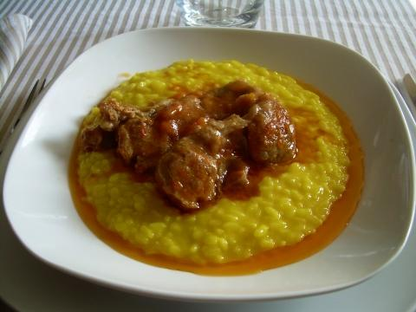
• 4 marrowbones
• 1 stalk celery
• 1 carrot, 1 small onion
• 1 sprig of parsley
• 350 grams tomatoes
• 100 grams butter
• 2 tablespoons of 'olive' oil
• 300 grams of rice
• 1 glass dry white wine
• 1 clove of garlic
• 2 tablespoons of white flour
• salt
• pepper
Preparation
Clean, peel and finely chop the vegetables and cook them in oil and butter. When they are well cooked(but not burnt!), add tomatoes and cook for few minutes. Cover the marrowbones with flour and add to sauce, put salt, pepper and then pour the white wine and cook for about an hour. Finally cook the rice in water until ‘al dente’ and drain. Put the marrowbones in a dish, cover with the juice, pour in all the rice and serve hot.

Fried potatoes à la mother
- Peel the potatoes
- Cut them into thin slices.
- Put them in the hot deep fryer for ca. 5 min.
- Season with salt and chicken spice.

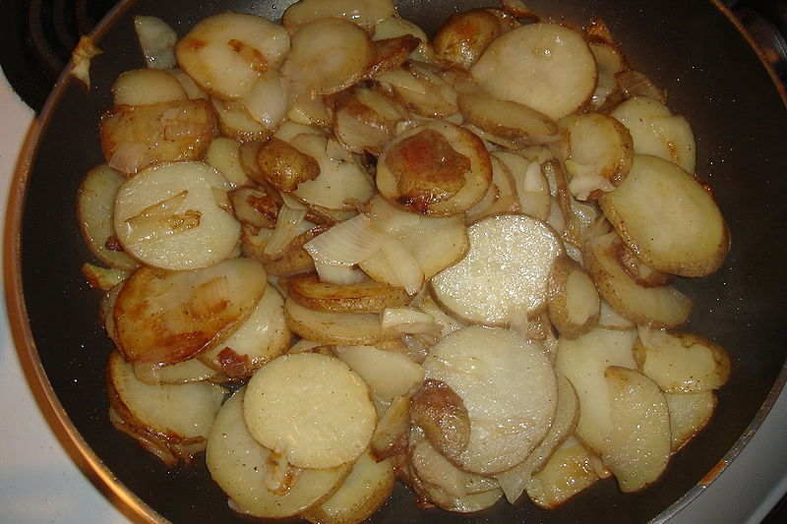

Potato Salad

Ingredients:
2,5 kg Potatoes
3-4 Packets of meat salad
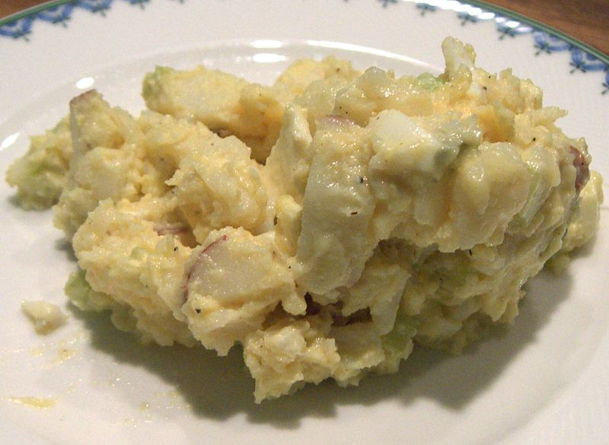
3-4 Pickled gherkins
2 Apples
1 Onion
Mustard
Preparation:
- Boil the potatoes.
- Peel the potatoes and cut them in small slices..
- Give the meat salad in a bowl.
- Cut the onion, the apples and the pickled gherkins and add them to the rest.
- Add some gherkin water and one teaspoon of mustard.
- Season with pepper and salt.

Apple cake

Ingredients
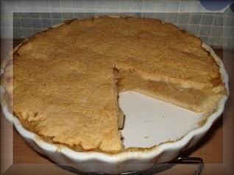
You will need:
450g flour
250g butter or margarine
180g sugar
1 kg grated apples
2 eggs
1 tea spoon of baking soda
1 vanilla sugar
cinnamon
1. Mix flour, sugar, butter and eggs with
2. Divide dough on two parts and roll them.
3. Place one part of the dough on a metal
plate; then put graded apples with cinnamon
and vanilla sugar on the dough and cover it
with second part of dough.
4. Give it to the oven and bake it on 180°C
for 30 minutes.
Tub Pancake

Ingredients :

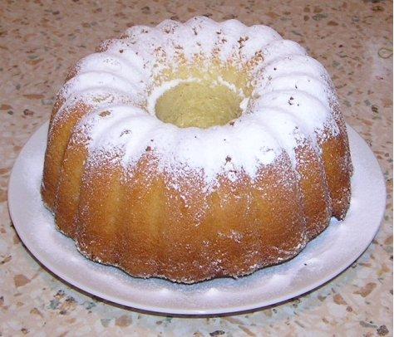
4 eggs
27 dkg icing sugar
1 packet of vanillic sugar
27 dkg very fine flour
1 packet of yeast powder
10 dkg water
10 dkg oil
Instructions:
Mix up yolks to foam. Then add icing sugar,
vanilic sugar ,water and oil and mix them together.
Mix flour with yeast powder and add it
to the mixture.
Whip egg-whites and add snow to bowl.
Mix all together gently.
Pour this mixture to a cake tin and put it
to oven at 180 degrees Celsia for 10 minutes.

Apple Crumble
Most farms would have a small orchard and so apples, pears and plums were commonly used in desserts and this recipe can be made with any of these fruits. It also has the advantage of being quick and simple to prepare and can be placed in the oven when the meat or the casserole is being cooked.
Weigh out 500g of plain flour into a bowl and add 250g of butter, cut into small cubes. Rub the flour and butter together until it resembles fine breadcrumbs. Add 3 tablespoons of castor sugar and mix loosely.

Peel, core and slice three large Bramley (cooking) apples into an oven proof dish and sprinkle with sugar to taste. Cover the apples with the crumble mixture and place in the oven for approximately 30 minutes or until the apples are soft. Test with a fork. Remove from the oven and sprinkle with more castor sugar. Serve with cream, ice-cream or custard.
Custard
Custard is a mixture of eggs, flour, sugar and milk but the easiest way to make it is by mixing 2 tablespoons of custard powder, 1 tablespoon of sugar and a small amount of milk taken from 1 pint, in a jug. Heat the rest of the milk in a saucepan and add slowly to the mixture. Return to the saucepan and continue to heat, stirring all the time, until it thickens.
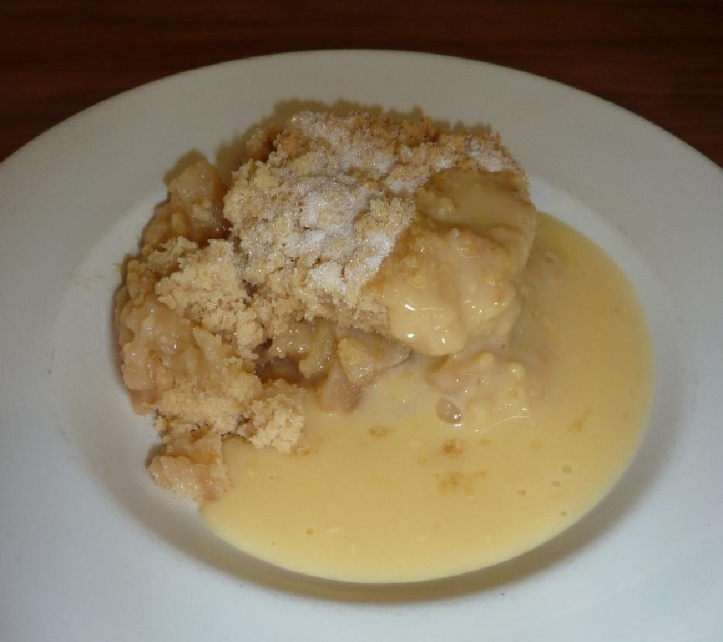

FIDEUÀ
Valencia is "the land of rice" and dozens of different rice dishes, however "Fideuà" is a very popular traditional main course similar to "paella." Cooked in a paella pan, it is made with noodles and seafood cooked in fish broth. "Fideuà" is quicker and easier than making "paella," and is as colourful and flavourful as well, making it a perfect dish for warm weather.

Prep Time: 20 minutes

Cook Time: 40 minutes

Total Time: 60 minutes

Ingredients:
- 1/2 lb. fish, such as tuna, halibut or shark
- 6 cups of fish or shrimp stock
- 1/2 lb. large prawns (20/pound)
- 1/2 lb. small clams
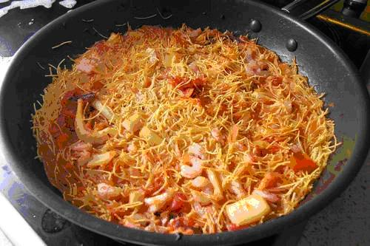
- 10 mussels
- 2 medium tomatoes
- 4 cloves garlic
- 2 dry red pepper corns
- 1/2 lb. squid
- 1/2 large red pepper
- 1 lb. vermicelli pasta
- 1/4 teaspoon saffron threads
- 4 to 6 oz. virgin olive oil
- salt to taste

Preparation:
Serves 6-8.
To prepare this recipe you will need a 17 inch (144cm) paella pan. Due to the size of the pan, we recommend that you cook the fideua on a kettle BBQ for even heat distribution. Assemble all the ingredients and kitchen equipment on a table near the BBQ, so that you can stay in the area and monitor the cooking.
Before performing the preparation tasks, light the BBQ. When the coals are covered in white ash, cooking can begin.

Clean and Prepare Shellfish
Rinse shrimp, mussels and clams under cold running water and set aside.
Pour fish or shrimp stock into a medium saucepan for use later. The stock should be warm.
Rinse fish and cut into 2” cubes. Clean the squid and trim tentacles. Slice squid into rings.
Slice red pepper into thin strips. Cut each tomato into 8 pieces. Peel garlic cloves and place in a mortar and mash with the pestle.
Place the paella pan on the BBQ grate and add enough olive oil to coat the bottom and allow the pan to heat up. When hot enough, sauté the shrimp and squid in the olive oil.
Add olive oil as needed to prevent sticking. Once the shrimp has cooked, it will turn pink. Remove the shrimp and squid from the pan and set aside. Leave the oil in the pan.
Put the diced tomatoes, slices of red pepper and mashed garlic in the olive oil with the two red pepper pods and sauté for two minutes.
Add the fish stock and saffron threads to the pan and stir. Bring broth to a boil.
When starts to boil, add the vermicelli and fish and stir. Spread the clams, mussels and squid around the pan and arrange the shrimp on top. Cook for 15 minutes, or until the pasta is “al dente.”

Remove Fideua from BBQ
Remove from BBQ, cover with aluminium foil and let it set for 5 minutes. Uncover and serve.

Suquet

Seafood Stew
Suquet is the diminutive form of suc, or 'juice', in Catalan, which means that this wonderfully flavoured dish is more correctly called juicy fish stew. The fish and shellfish used vary from cook to cook, and so does the amount of liquid - in fact, some people call this a stew, while others call it a soup - but saffron and almonds are typically part of the mix.

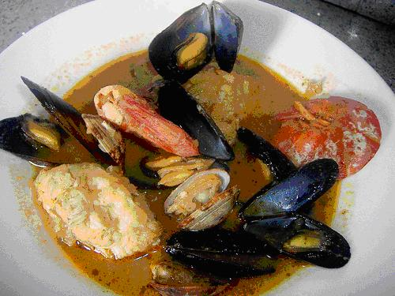

Ingredients
- 12 Manila or small littleneck or cherrystone clams
- 1 tablespoon coarse salt
- 1/2 cup olive oil
- 2 clove garlic peeled but left whole
- 8 blanched almonds
- 1 Tablespoon chopped fresh flat-leaf parsley
- 1 tablespoon water
- 1 yellow onion, finely chopped
- 1 tomato, halved crosswise, grated on the large holes of a handheld grater, and skin discarded
- Pinch of saffron threads
- 6 cups fish stock
- 2 pounds monkfish fillet, cut into small pieces
- 1 pound hake fillet, cut into small pieces
- 1 pound squid, cleaned and cut into thin rings
- 6 large shrimp in the shell with heads intact
- 12 medium shrimp, peeled
- 1/2 pound mussels, scrubbed and debearded
1/2 cup cava or sparkling white wine
Preparation
Scrub the clams under cold running water, discarding any that fail to close to the touch. In a large bowl, combine the clams, coarse salt, and water to cover and let stand for at least 30 minutes or up to 2 hours so that the clams release any sand trapped in their shells.
Meanwhile, in a deep cazuela, heat the olive oil over high heat. Add the garlic and fry, stirring often, for about 1 minute, or until golden. Using a slotted spoon, transfer the garlic to a mortar. Reserve the oil in the cazuela off the heat.
Add the almonds, parsley, and water to the mortar and pound with a pestle until a paste forms. Set aside.
Return the cazuela to medium heat, add the onion, and sauté for 5 minutes, or until soft. Add the tomato and saffron, mix well, and cook for 5 minutes longer to blend the flavours. Meanwhile, in a saucepan, bring the stock to a boil, then decrease the heat to maintain a gentle simmer.
Add the monkfish, hake, and large and medium shrimp to the cazuela and mix well with onion and tomato. Stir in 1 cup of the hot stock and cook for 30 minutes, adding the remaining stock 1 cup at a time at 5-minute intervals. At the end of this time, all the fish will be cooked and the flavours will be blended.
Season to taste with salt. Drain the clams and add them to the cazuela along with the mussels, discarding any that fail to close to the touch, and cava. Cook for 5 minutes longer, or until the clams and mussels open.
Discard any mussels or clams that failed to open. Serve immediately.

Soda Bread & Potato Bread
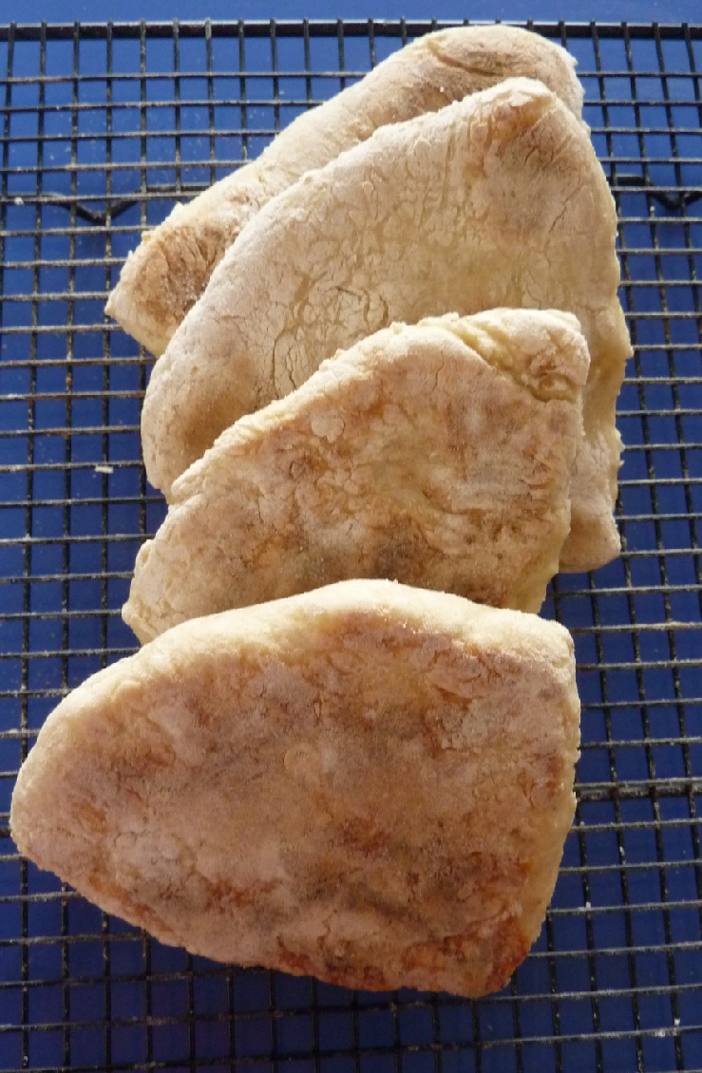
Traditional Irish breads are flat breads as people used to cook them on a flat plate above the fire called a griddle. Today you can buy griddles which can be placed on the top of your cooker. They also don’t have any preservatives in them so must be baked fresh every couple of days.

Ingredients
200 g Plain Flour
Half a teaspoon of baking soda
Half a teaspoon of salt
2 teaspoons of sugar
Fresh buttermilk

Method
Sieve together the flour, baking soda and salt and add the sugar. Make a well in the centre and gradually mix in the buttermilk to form a soft dough. Press the dough out into a round and cut into quarters or farls. Sprinkle flour on a flat griddle and heat until the flour begins to turn brown. Cook for a few minutes on each side. The bread is cooked when there is a hollow sound when tapped on the bottom. Serve with butter, cheese or jam.
Potato Bread
Peel, boil and mash 200g of potatoes and add handfuls of flour, working the ingredients together to form a soft dough. Press out into thin rounds and cut into farls. Cook for approximately 5 minutes on the griddle until brown on each side. Serve with butter.
When the bread is a couple of days old it can used up by frying it as part of the Ulster Fry.

