Slovak sauerkraut soup Polievka z kyslej kapusty
Ingredients: Suroviny:
250 g pork chop 250 g bravčového rebierka
2 – 3 sausages 2 – 3 klobásky
1 teaspoon salt 1 lyžička soli
1 onion 1 cibuľa
black pepper čierne korenie
30 g dried mushrooms 30 g sušených húb
1 teaspoon red pepper 1 lyžička mletej papriky
200 g sauerkraut 200 g kyslej kapusty
5 teaspons sugar 5 lyžičiek cukru
100 potatoes 100 g zemiakov
30 g garlic 30 g cesnaku
50 g bacon 50 g slaniny
1 dl sour cream 1 dl kyslej smotany

Instructions: Príprava:

1. Fry bacon cut into little cubs, add onions and 1. Osmažte slaninku pokrájanú na kocky,
when onion is fried, add red pepper and pour osmažte cibuľku, pridajte červenú pap-
1 litre of water. riku a zalejte 1 l vody.
2. Put in sauerkraut, pepper and other seasonings. 2. Pridajte kyslú kapustu a koreniny.
3. Put meat, cut into cubes into boiling soup, then 3. Do vriacej polievky dajte mäso, potom
sausages and at the end mushrooms and potatoes. klobásku a nakoniec zemiaky a sušené
4. Cook until soft and when the soup is ready, huby.
serve with sour cream. 4. Varte domäkka a hotovú polievku po-
dávajte s kyslou smotanou

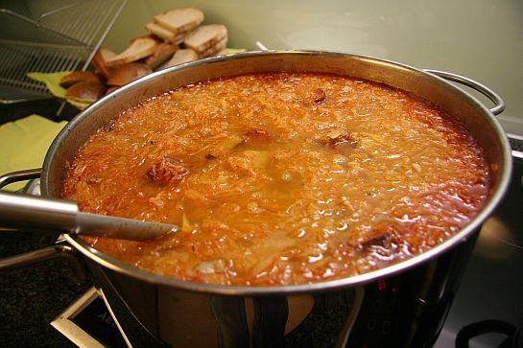

This soup is typical Slovak Christmas dish. People in some regions cook it also with dried plums.

4

