Food in Slovakia

Most people in our country cook and prepare their meals at home. They usually have breakfast between 6 and 7 o´clock, lunch between 12 and 2 o´clock and dinner between 6 and 7 o´clock.
On weekdays they usually have a small breakfast - bread and butter or cheese, breadrolls or cakes. They drink tea, milk, cocoa or coffee. At the weekend they prefer ham and eggs, sausages and vegetables.
The lunch consists of soup and main meal. People usually have for lunch some kinds of the meat like pork, beef, fish or chicken, with rice, potatoes and vegetables. But lots of people eat vegetarian food like: fried cheese with chips, pasta, pancakes or mixed salads. Lots of people like pizza, too. They drink mineral water, tea, fruit juice, beer or wine.
For dinner they have similar things like for lunch or they have light supper – scrambled eggs, sausages or toast.
On working days lots of people go for lunch to the restaurants and they choose their meals from daily menu. Most children have their lunch at school.
Between main meals people usually eat some fruit like apples, bananas, oranges, satsumas, grapes and also nuts, yoghurts, pudding, some sweets or chocolate.
Most people buy their food at shops and big supermarkets and fresh vegetables and fruit at markets.
In all towns and cities there are many restaurants, where people can have their lunch or dinner. At present Mac Donalds and Fast Food restaurants are very popular, especially among children. They love burgers, hot dogs, chips and Cola. All around the country there are also pizzerias visited by families, especially at the weekend. In cafés or confectioneries people can get cakes, ice-cream, coffee or fruit juice.

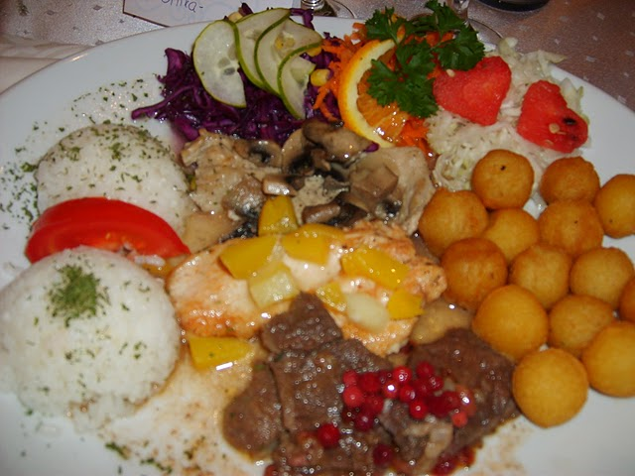
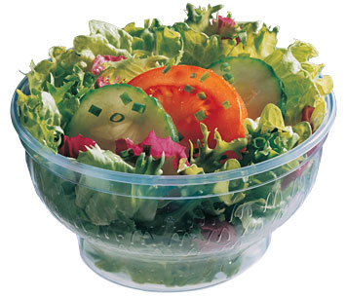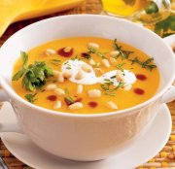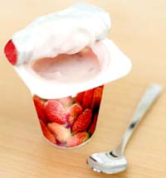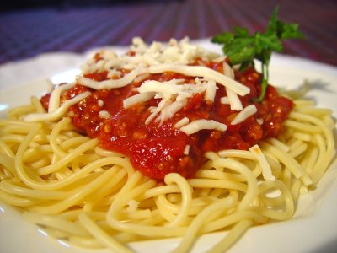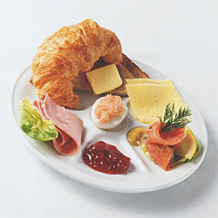

1
Slovak Sheep Cheese Gnocchi Bryndzové halušky

Ingredients: Suroviny:

500 g potatoes 500 g zemiakov
100 g smooth flour 100 g hladkej múky
1 egg 1 vajce
1 teaspoon salt 1 lyžičku soli
½ dl milk ½ dl mlieka
200 g bacon 200 g slaniny
200 g Slovak sheep cheese / „bryndza“/ 200 g bryndze

Instructions: Príprava:

1. Peel potatoes and grate them. 1. Ošúpte a postrúhajte zemiaky.
2. Mix them with milk, flour, salt and egg. 2. Vymiešajte ich s mliekom, múkou, so-
3. Put the batter on a cutting board and with ľou a vajcom.
a knife cut little pieces into the boiling 3. Dajte cesto na dosku a nožíkom odkra-
water. jujte malé kúsky do vriacej vody.
4. Stir until the gnocchi float to the top. 4. Miešajte, až kým halušky nevyplávajú.
5. Take them out and rinse with cold water. 5. Vyberte ich a opláchnite studenou vodou
6. Mix them with sheep cheese and some milk. 6. Rozmiešajte ich s bryndzou a mliekom.
7. Top with fried bacon before serving. 7. Pred podávaním polejte osmaženou slanin-
kou.
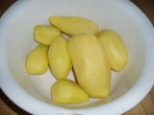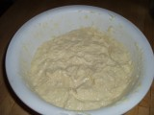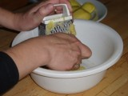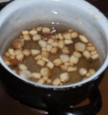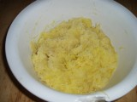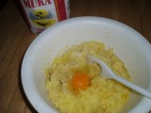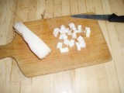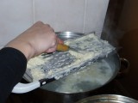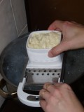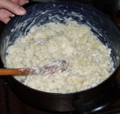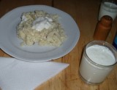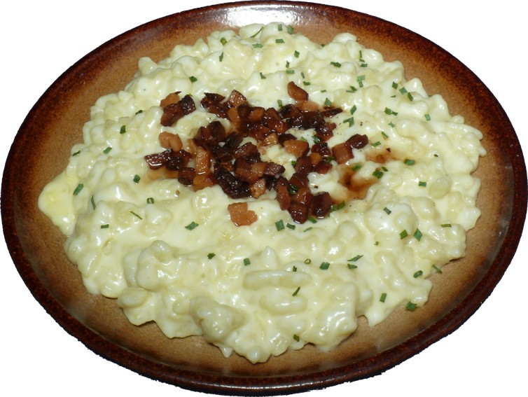

2

